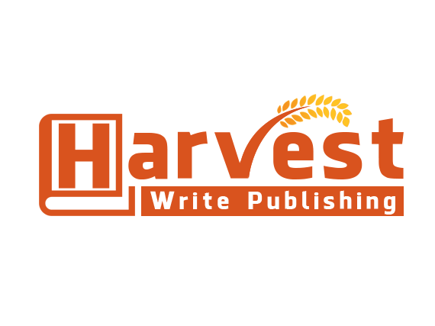

**VERBAL MESSAGES TRANLATED INTO A BOOK!**

**QUESTIONNAIRE**

TITLE OF WORK:

AUTHOR NAME:

* How many messages will need to be translated?
* Message length 20, 40, 60 minutes or more? If you have more than one recording – list each recording length. (i.e. audio one has 35 minutes, audio two 40 minutes, etc.)
* Are you self-publishing?
* Projected date of book release?
* Will you need content editing services?
* Will you need proofreading services?

Save document as verbal translations

(Insert your name and book title, ex. The Way it Goes Smith) and return to info@harvestwritepublishing.com